Cloud Computing Final Project Report

Topic: Blood Bank Management System

Team Information:

**Name**: Jasmin Joy,

**Student ID:** 16335976,

**Photo**:



Motivation/Purpose:

The blood bank plays an important role in the process of collecting blood and managing blood stocks, approving blood requests, updating donations and updating available blood types. By using an online system we can create a more transparent network which can be used to address the issues and problems encountered in collecting information about donors, inventories of blood etc. Blood Bank Management system will greatly increase the safety and quality of the blood supply as well as provide logistics data for the optimal supply.

System Architecture:

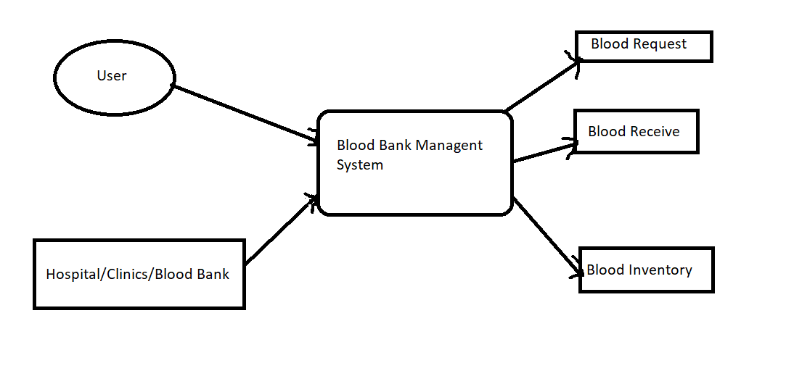

Technology Used:

* Frontend: HTML, CSS, Bootstrap, PHP
* Backend: SQL Database
* Cloud Hosting: AWS EC2 Instance by Using remote desktop.
* Software Used: Xampp, Virtual Studio.

**Steps you have taken to make the service:**

The Blood Bank Management System is a hosted website on the internet which act as a intermediatory between Hospital and Users who require the blood or are willing to donate or have blood in stock.

**Main Webpage:** Gives Basic information about the purpose of the website.

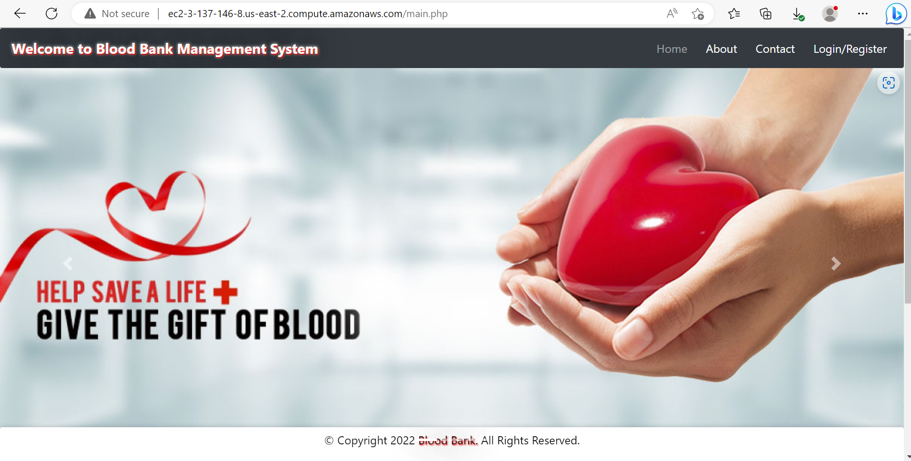

**About Us:** This gives information about the organization that is hosting and managing the website.

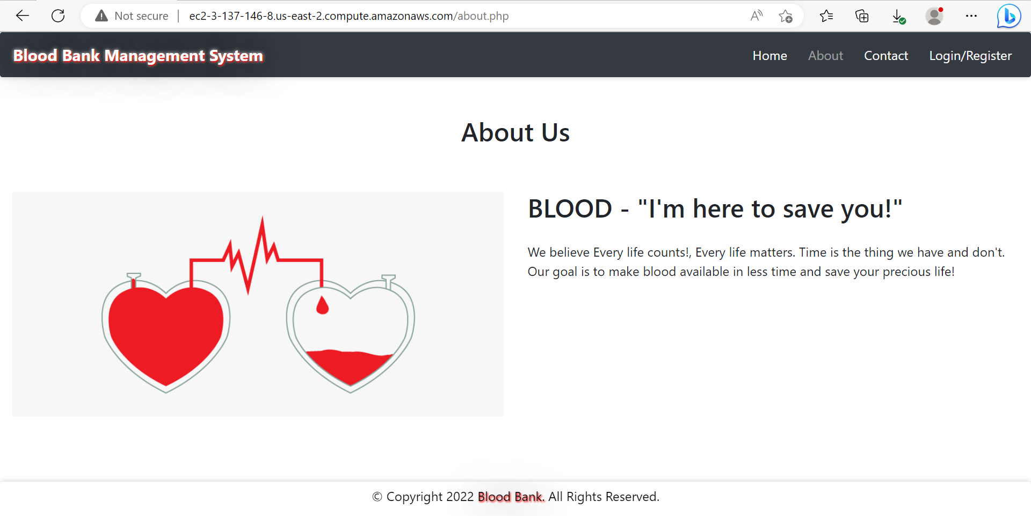

**Contact:** This page gives information regarding the contact information.

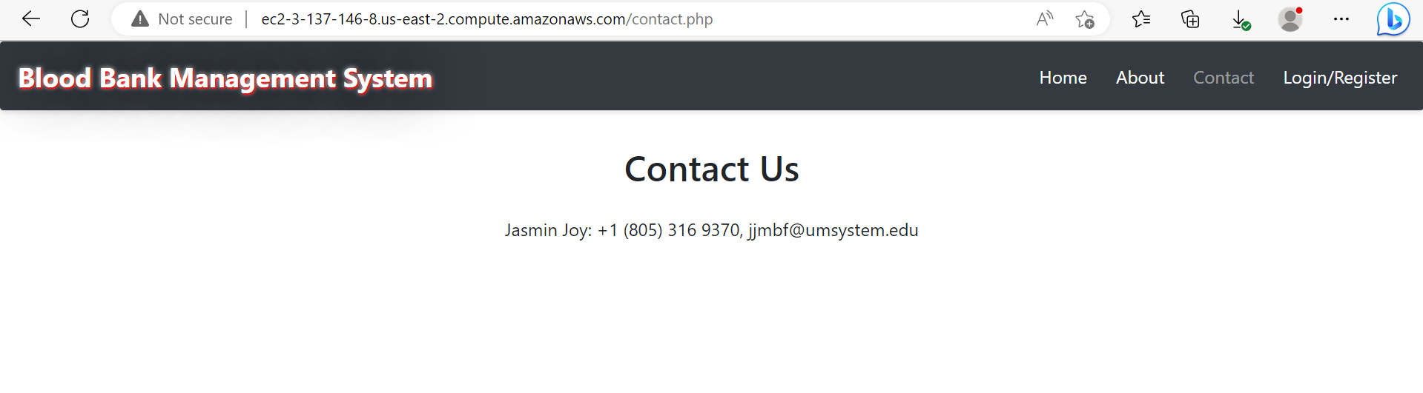

**Login/Registration:** This page can be used by Users or Hospital to register in the website.

Register new User or Hospital:

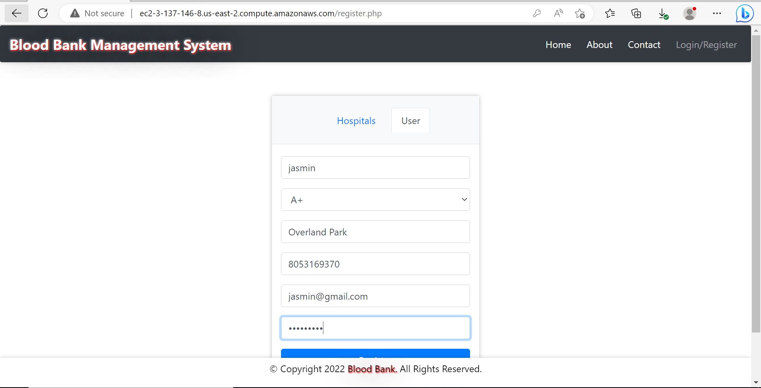

**Login as User or Hospital:**

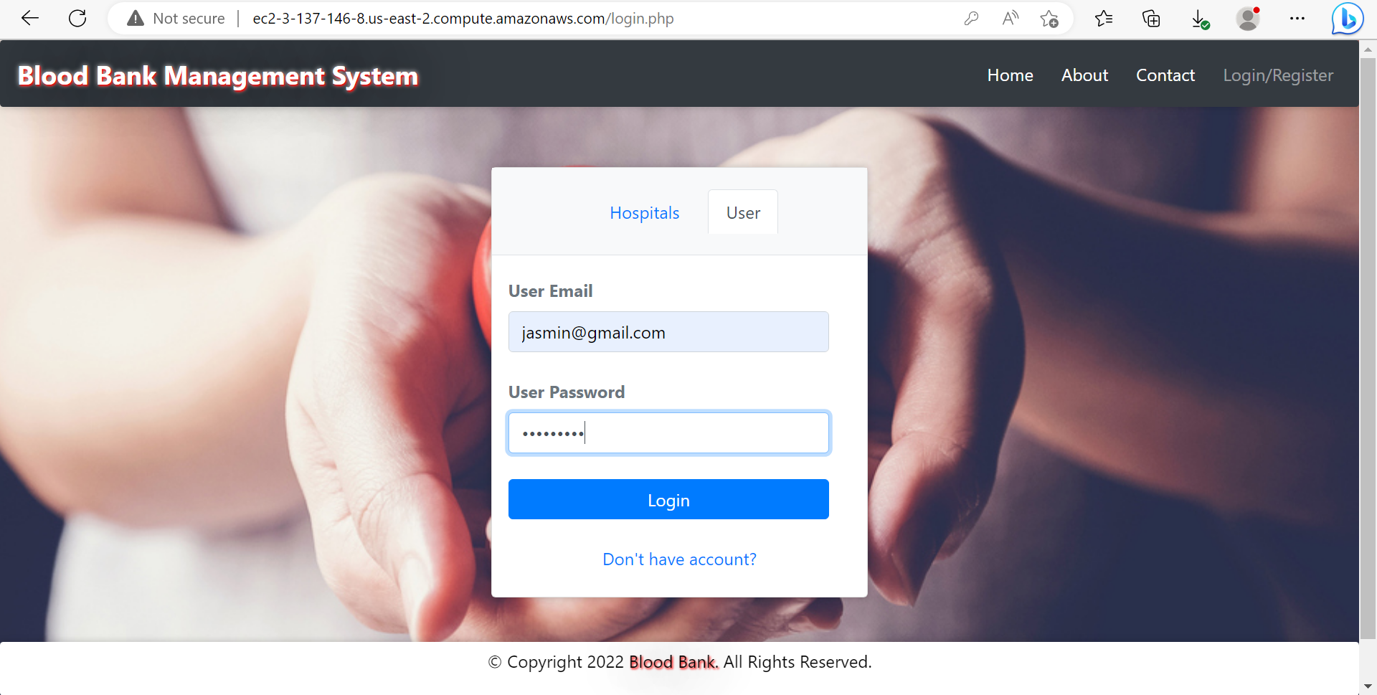

**Welcome page for User:** When we login as a known user using email ID and Password we get this welcome page.

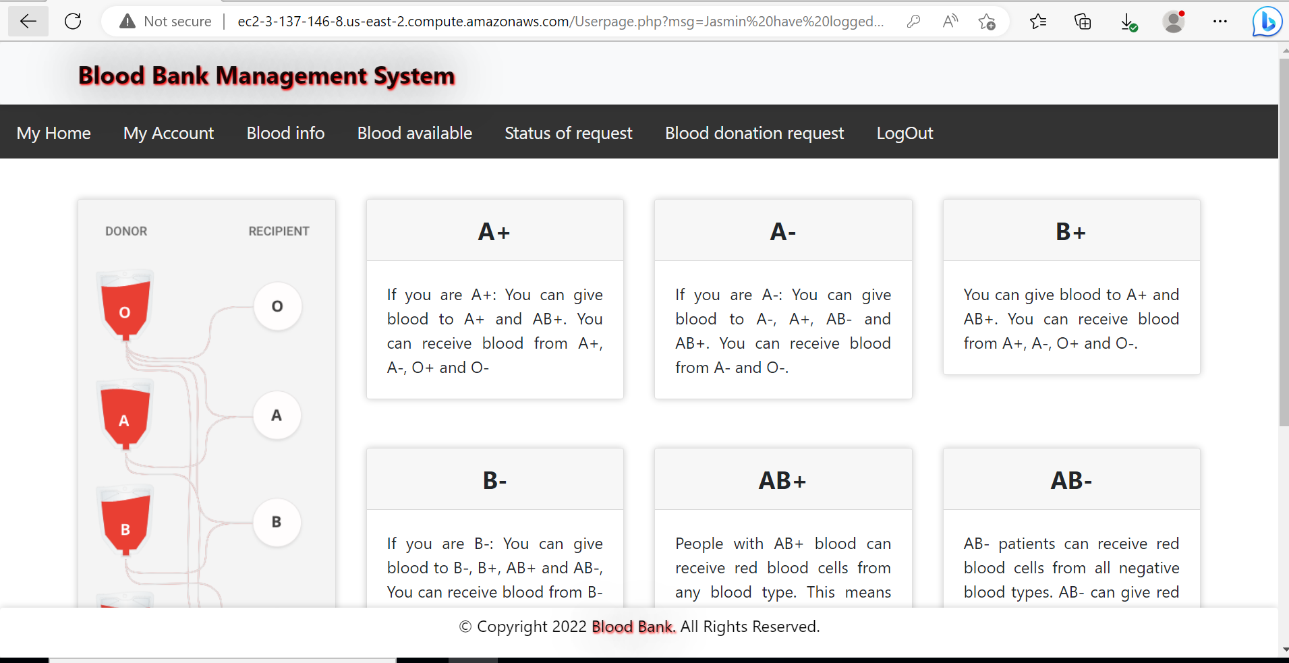

We can avail below services as a User:

**Blood Info:** Give Information about the people who we know are willing to donate the blood.

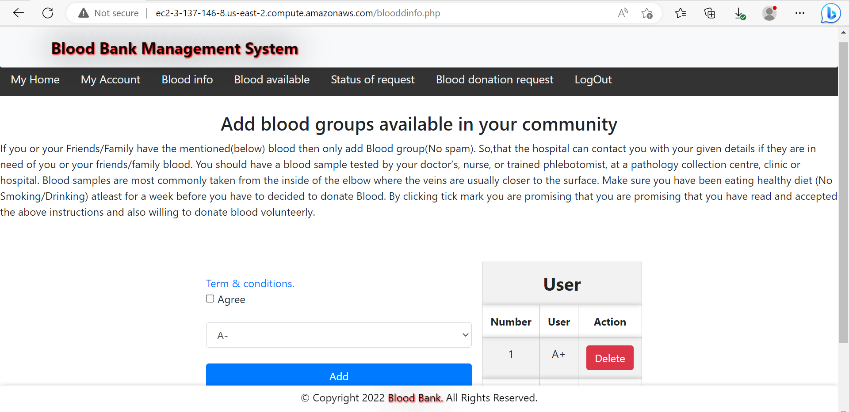

**Blood Available:** Contains information on all the blood that is currently available and their location. We can add request for the blood.

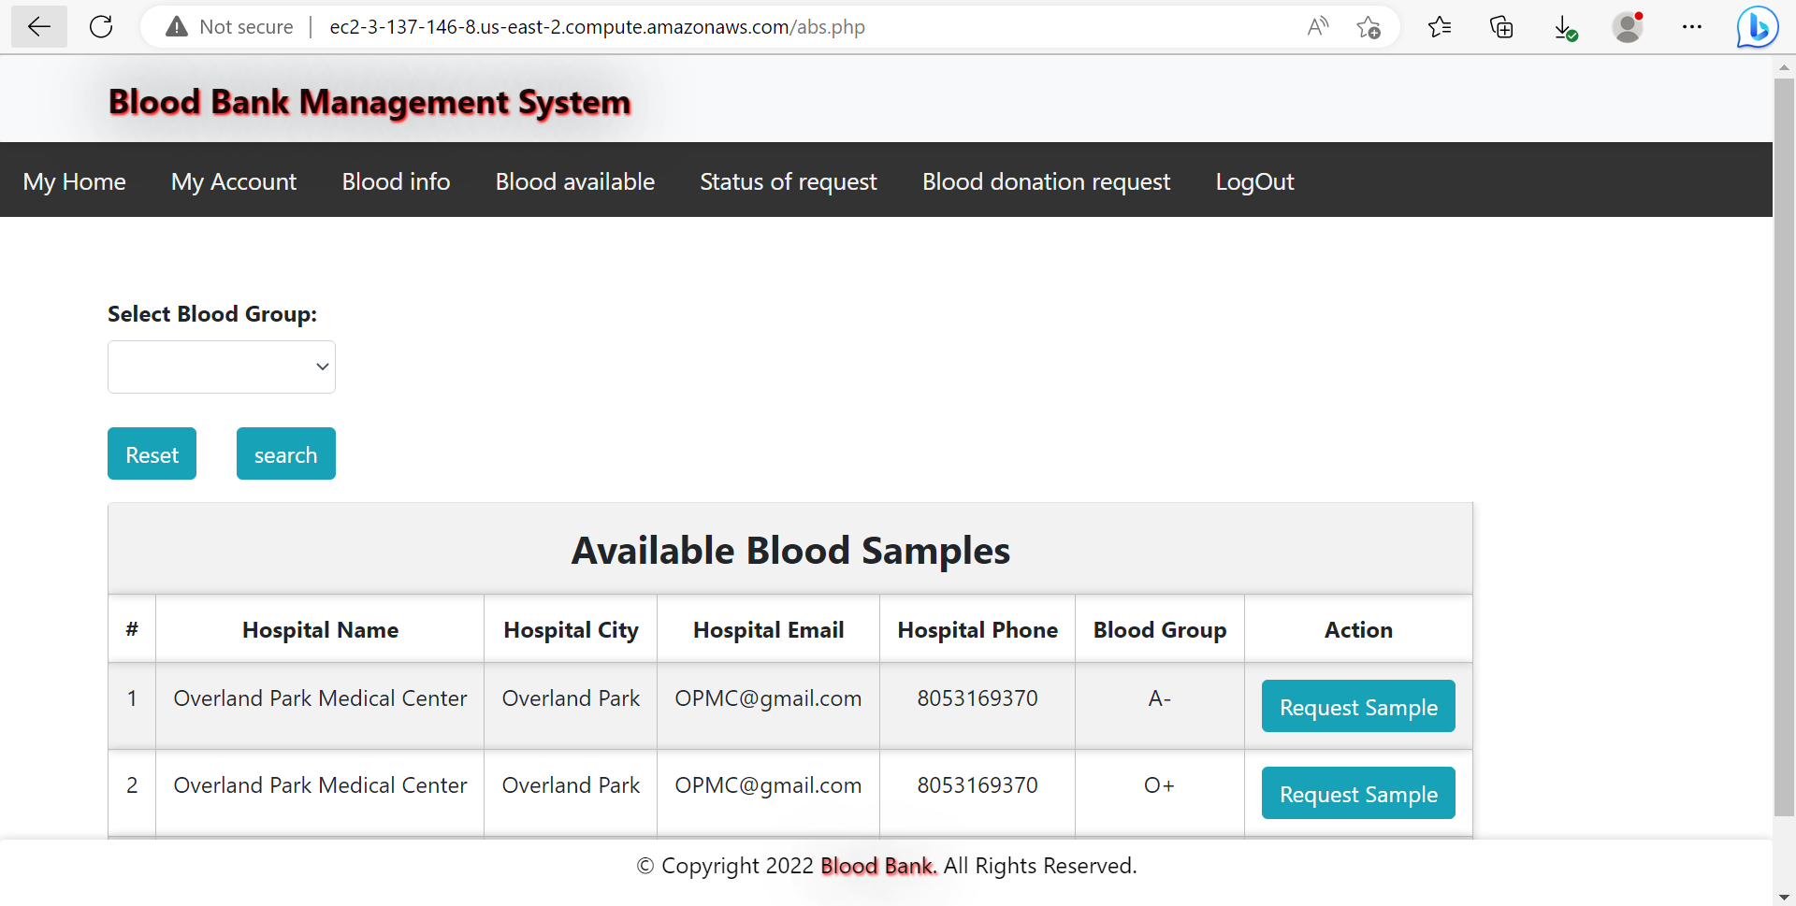

**Status of Request:** This will contain the status of our request.

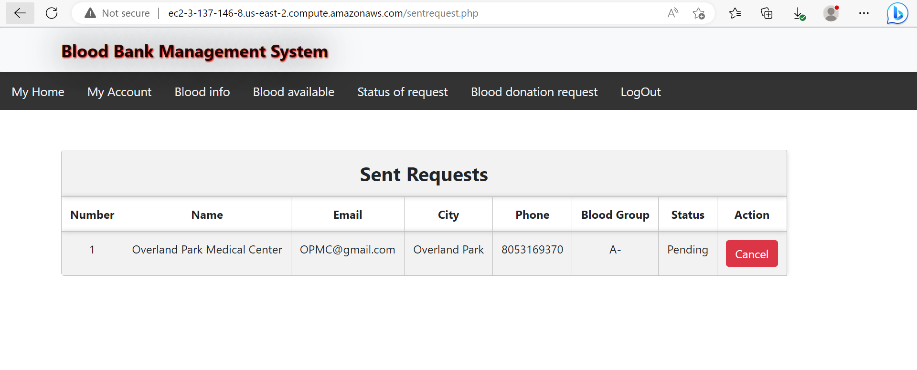

**Blood Donation Request:** This webpage will let us know if we are eligible to donate any currently available Blood donation request.

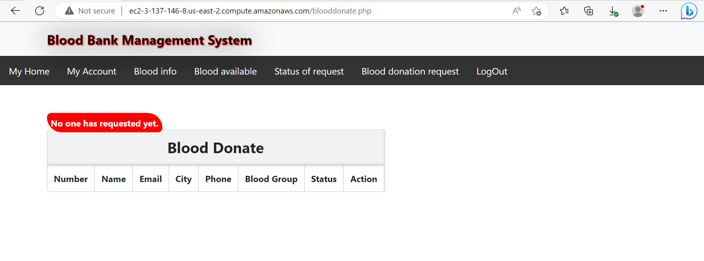

**Welcome page for Hospital:** When we login as a known Hospital using email ID and Password we get this welcome page.

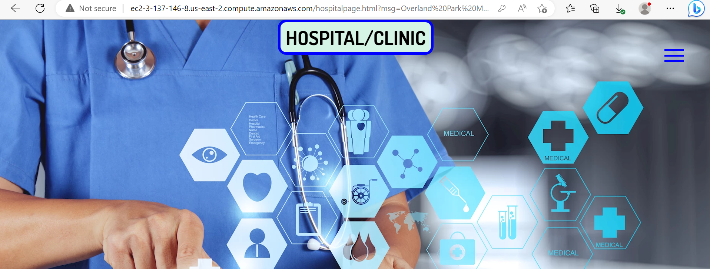

**Stock of Blood:** This page gives us the information about blood that is available in the Hospital Bank.

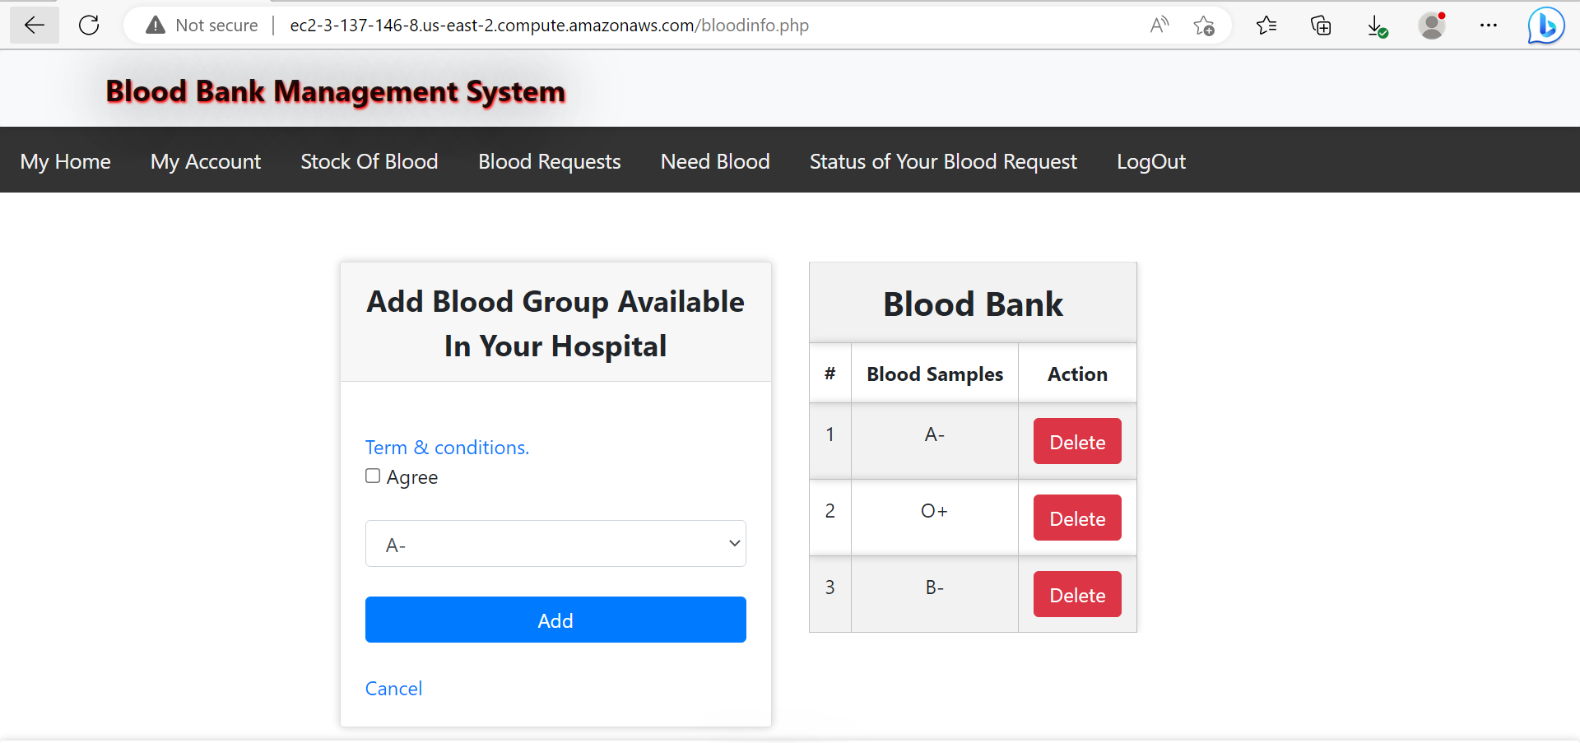

**Blood Request:** In this page we get information regarding all the request that we have received for blood donation.

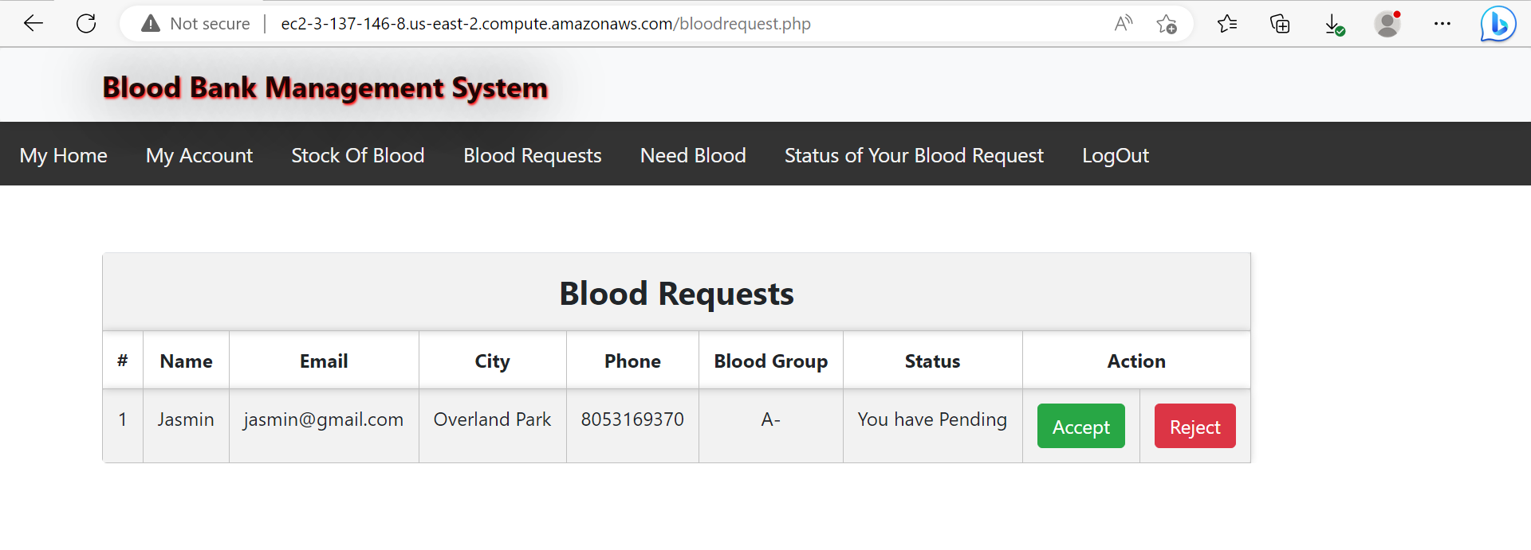

**Need Blood:** In this page we can inform other Hospitals/Users about requirements of the blood.

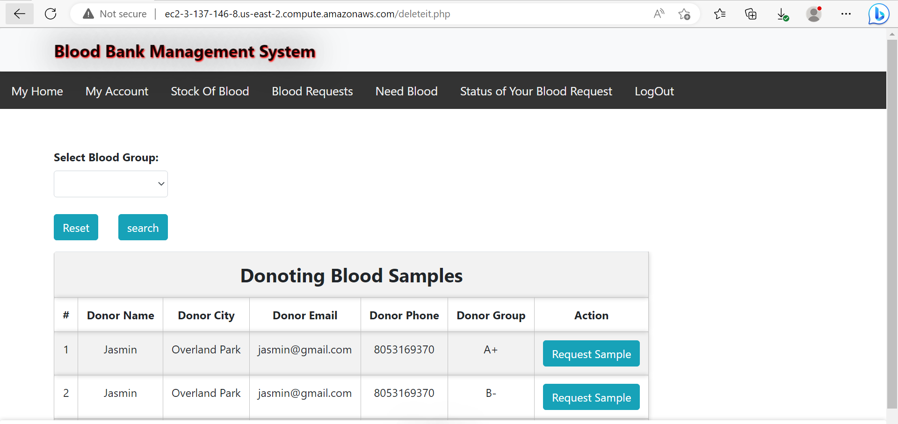

**Status of Blood Request:** In this page we can get the status of our request.

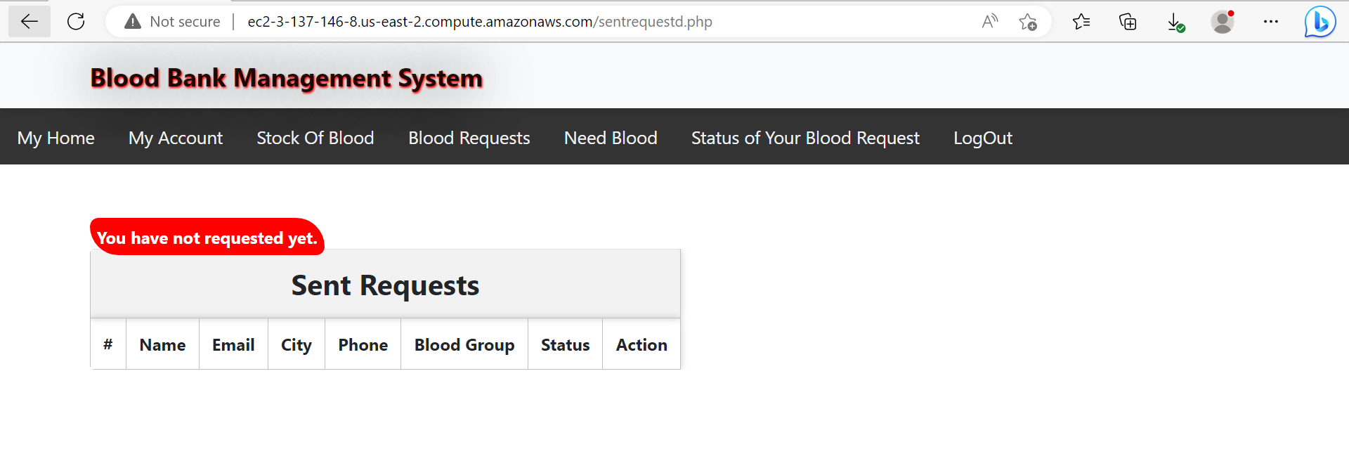

**Logout:** This tab is used to logout and it will take us back to Home.

**Cloud Platform:**

**Instance Creation and information:**

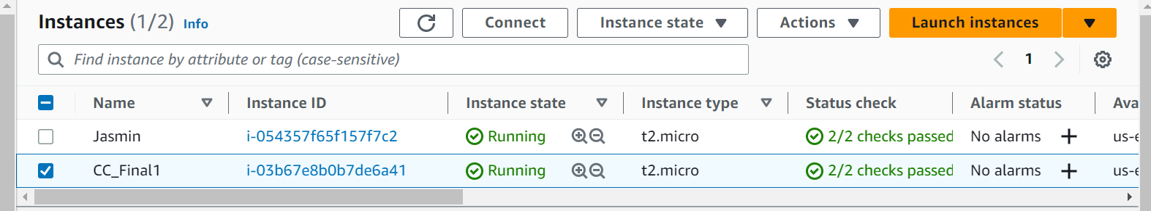

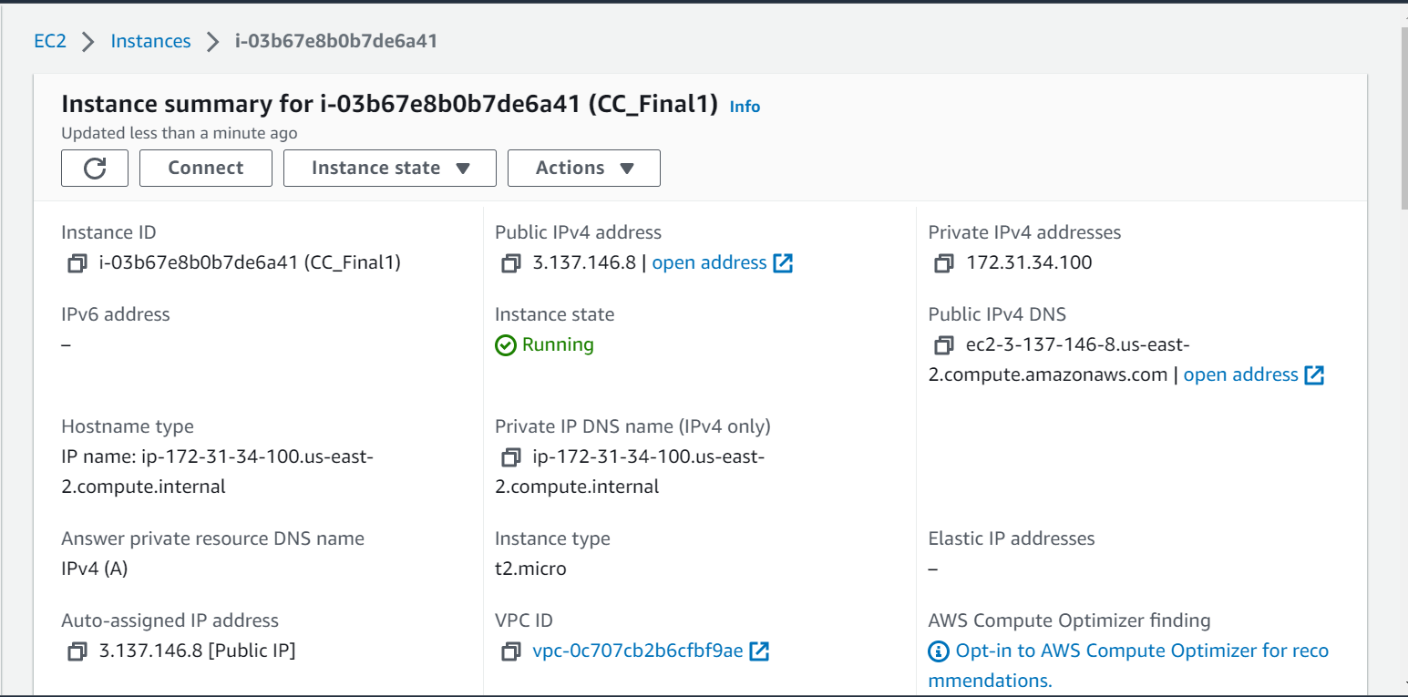

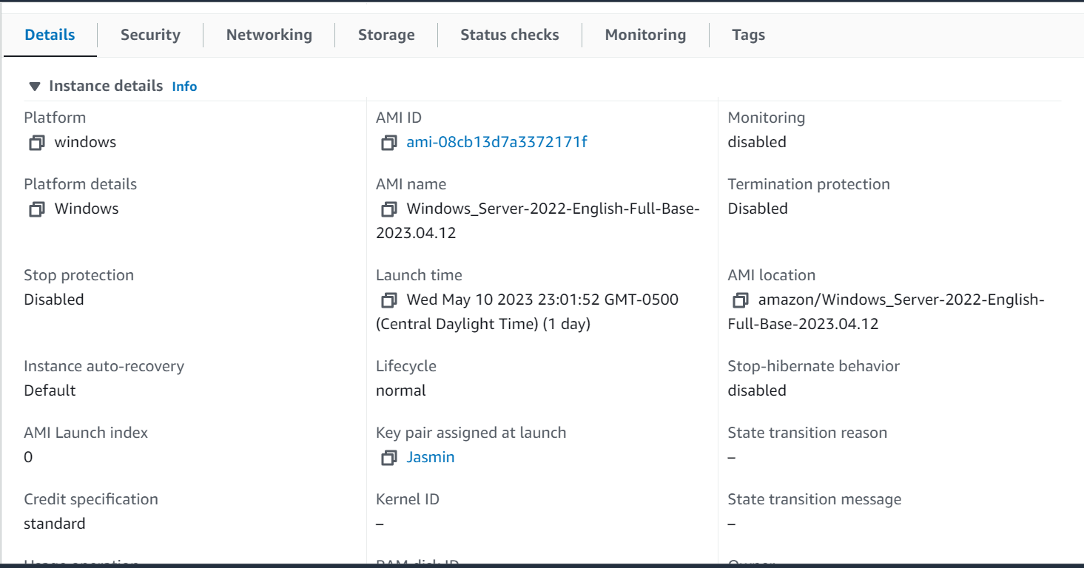

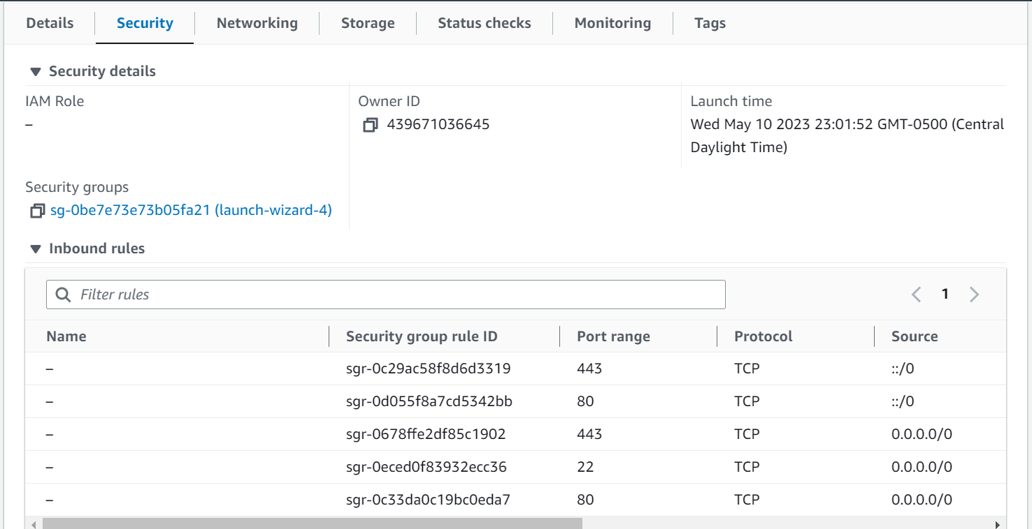

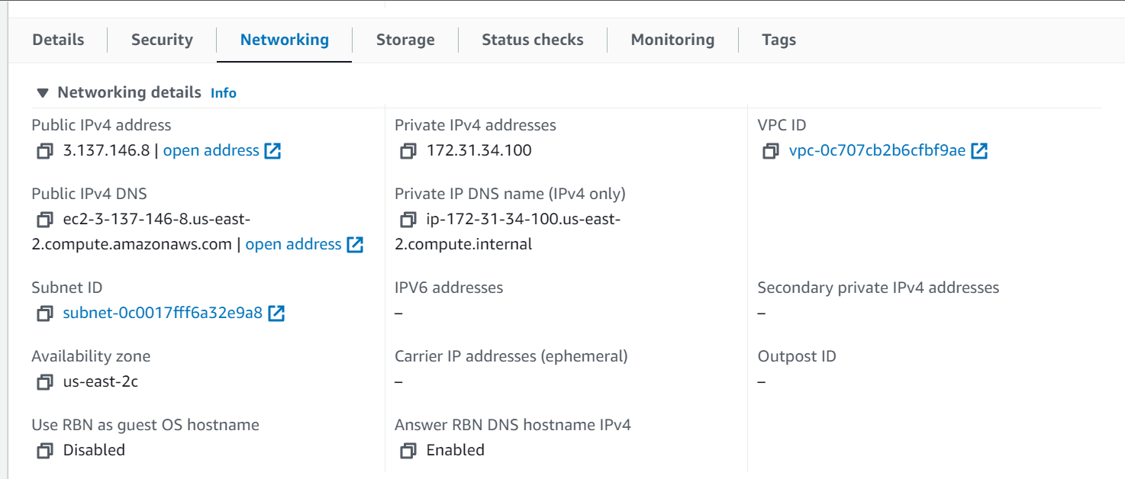

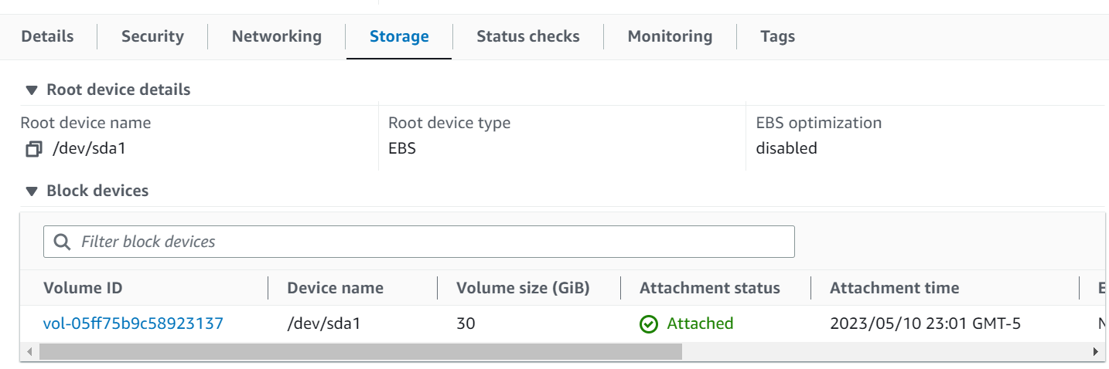

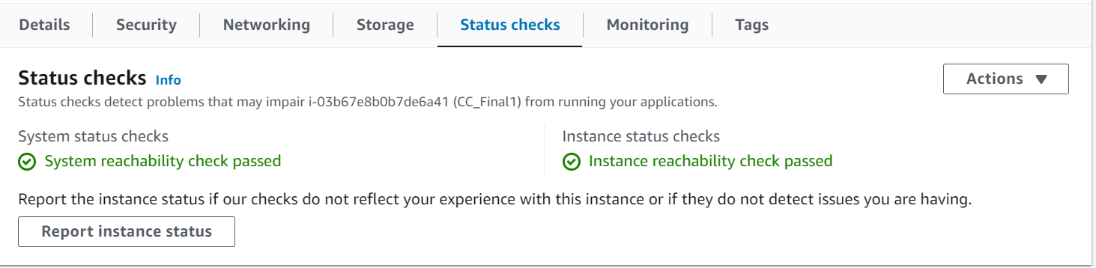

Externally accessible website: [ec2-3-137-146-8.us-east-2.compute.amazonaws.com](https://ec2-3-137-146-8.us-east-2.compute.amazonaws.com))/main.php

Link to the codes: https://github.com/JasminJoy1/CC_Final.git

The link to the demo video: https://github.com/JasminJoy1/CC_Final/tree/78662cc6272c5539fa6597118398bc64aeacf11f/Video